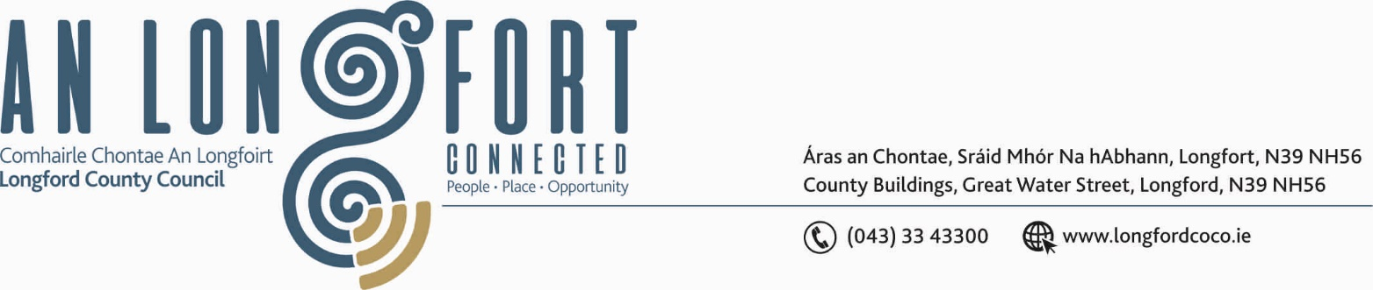

GRANARD MUNICIPAL DISTRICT

Corporate Affairs,
Aras an Chontae,
LONGFOIRT.

16th January 2019.

To: Each Member of Granard Municipal District.

Dear Member,

You are requested to attend Meeting of Granard Municipal District to be held in
Granard Community Library on Tuesday, 22nd January 2019 at 3.30 p.m. to transact business, as set out on the Agenda hereunder.

Yours sincerely,
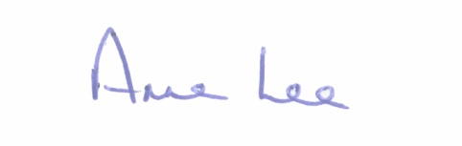

_______________
Anne Lee,
Meetings Administrator.

AGENDA

Prayer before meeting.

1. Confirmation of the Minutes of Granard Municipal District Meetings held on the 27th November 2018 – copy enclosed.

2. Matters arising from Minutes.

3. Area Engineer’s Progress Report.

4. Consideration and adoption of Draft Municipal District Report for inclusion in Longford County Council 2018 Annual Report - enclosed.

5. Consideration of Nominee for the 2019 Cathaoirleach Awards.

6. Correspondence - circulated.
(a) Letter dated 24th October 2018 regarding the formation of Town Team in Granard.

::::::::::::::::::::::::::::::::::::

